Validating primary and hospital care resource use and costs based on OMOP-mapped CPRD data against corresponding source data: the case of postmenopausal fragility fractures in the UK

Analysis plan V.1

Background
Common Data Models (CDMs) standardize electronic healthcare records from various sources, facilitating improved usability and interoperability of real-world data across different settings. CDMs, such as the Observational Medical Outcomes Partnership (OMOP) model, are increasingly used to generate evidence in key areas of pharmacoepidemiology, including medical product safety surveillance, comparative effectiveness research, and risk prediction.

The feasibility of applying CDMs in health economics has been demonstrated in a previous study, where we estimated healthcare resource utilization and costs of imminent fractures across six European countries using OMOP-CDM data. However, the validity of OMOP-CDM mapped data for health economics research remains to be fully established.

Aims and objectives
The overall aim of this study is to assess the validity of primary and hospital care resource use and costs estimated based on OMOP-mapped CPRD data against its corresponding source data using a cohort of women with postmenopausal fragility fractures in the UK.

The specific objectives are the following:
- To estimate the use of primary care resources by the cohort of interest in terms of number of visits to relevant healthcare professional per person per year using the mapped dataset and compare results to the same analysis using the source dataset.
- To estimate the cost of primary care in total and by relevant healthcare professional per person per year using the mapped dataset and compare results to the same analysis using the source dataset.
- To estimate the use of inpatient hospital care by the cohort of interest in terms length of stay, and number of admissions in total as well as by primary diagnosis and primary procedure per person per year using the mapped dataset and compare results to the same analysis using the source dataset.
- To estimate the fracture-related cost of inpatient hospital care by the cohort of interest in total and by primary diagnosis and primary procedure per person per year using the mapped dataset and compare results to the same analysis using the source dataset.
- To estimate the use of outpatient hospital care by the cohort of interest in terms of number of consultations in total and by service (specialty) per person per year using the mapped dataset and compare results to the same analysis using the source dataset.
- To estimate the cost of outpatient hospital care by the cohort of interest in total and by service (specialty) per person per year using the mapped dataset and compare results to the same analysis using the source dataset.
- To estimate the use of emergency hospital care by the cohort of interest in terms of number of visits in total and by service (specialty) per person per year using the mapped dataset and compare results to the same analysis using the source dataset.
- To estimate the cost of emergency hospital care by the cohort of interest in total and by service (specialty) per person per year using the mapped dataset and compare results to the same analysis using the source dataset.

Methods

Datasets

CPRD-HES (source data):
The Clinical Practice Research Datalink (CPRD) is a governmental, not-for-profit research service, consisting of data collected from a network of UK GP practices for all ages. This includes conditions, signs and symptoms, measurements, procedures and prescriptions recorded in and about contacts between the patient and the GP practice. The major data elements contained within this database are prescriptions given by the GP and clinical, referral, or test events that are recorded by the GP. The database contains the patient’s year of birth and date of death. CPRD AURUM will be used, which contains more than 40 million patients, covering 15% of UK general practices. CPRD is also linked to Hospital Episode Statistics (HES) Admitted Patient Care, Accident and Emergency, Outpatient, as well as mortality data from Office of National Statistics.

OMOP-CDM (mapped data):
CPRD-HES was accurately transformed into the OMOP CDM, with acceptable information loss across drugs, conditions and observations. The mapping was already conducted for our previous study with the same population of interest.

Study design

Study period
The patient selection period is from 01 April 2010 to 31 March 2018. Patients are required to have ≥730 days observation time prior to the index date and will be followed-up for a maximum of 730 days. Therefore, the study period is from 01 April 2008 to 31 March 2020.

Study population selection criteria
The study will include all women aged >50 years with an incident fragility fracture. Age of 50 years will be used as a surrogate cut-off to identify postmenopausal status given its poor recording in routinely collected data.

Inclusion criteria:
- Patients with a first recorded fracture in any site except the face, skull or digits and no history of fracture in the two years prior.
Exclusion criteria:
- Less than 730 days observation time prior to index date
- at any time prior to and including the index date, occurrence of:
  - cancer (except non-melanoma skin cancer),
  - Paget's disease of the bone,
  - other metabolic bone diseases (e.g., osteomalacia, hyperparathyroidism, osteogenesis imperfecta)
  - traumatic fractures defined as fractures occurring on the same day as trauma codes, three fracture records of different sites on the same day, or one record that mentioned three different sites.

The index date is defined as the date of the first recorded fracture occurring between April 1, 2012, and March 31, 2018.

Fractures are identified based on primary care records (Aurum in raw, condition_type_concept_id == 32827 in omop).

Outcomes
The outcomes of interest are primary and secondary healthcare resource utilisation and direct costs associated to first incident fracture measured during the 730 days post index date or until a censoring event occurs and expressed as values per person/year.

Censoring events are:
- fracture ensuing incident (index) fracture,
- cancer (except non-melanoma skin cancer),
- Paget’s disease of the bone, or other metabolic bone diseases,
- death,
- end of data collection period,
- maximum of 730 days from index date.
Figure 1: hypothetical scenario of how patients could contribute to the analysis.



For subsequent fractures occurring at the same site as the incident fracture and on the same day, we will keep one record to account for possible re-recordings of the same fracture.
A washout period of 90 days will be applied to account for the likelihood that the posterior record refers to the same index fracture (a re-recording). Since the underlying data represent attended medical care, it is assumed that absence of information of clinical events or about use of resources means absence thereof.

Analysis
Resource use and costs will be estimated per person per year, with the numerator indicating the sum of resource use or costs for the cohort over the exposure period and the denominator capturing the total exposure time of the cohort accounting in this way for any censoring event.

Pre-existing code will be used to generate mean and median HCRU and costs per patient/year in the mapped dataset and bespoke code will be developed to reproduce the same estimation on the source data. An outline of the logic used in the pre-existing code developed in OMOP-CDM is illustrated in Figure 2.

Figure 2: logic used in pre-existing code for the OMOP-CDM analysis

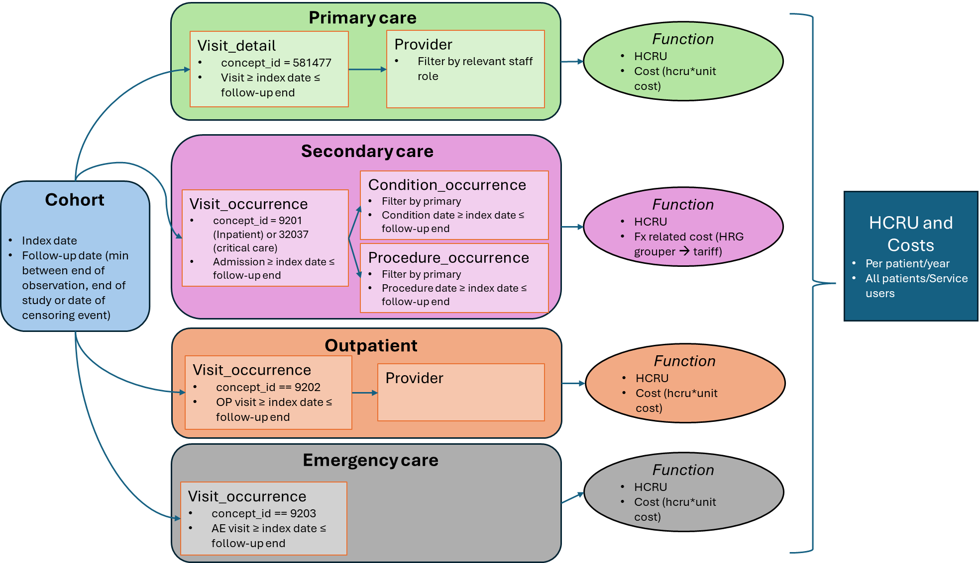

Estimates will be provided for all patients in the cohort, as well as for service users only.

Service users are defined as patients with records of healthcare encounters with the NHS and their resource use and associated costs will be estimated separately for primary care (hence excluding patients with no record of primary care visits with any relevant healthcare staff), secondary care (excluding patients without inpatient or critical care admission), outpatient (excluding patients with no records of outpatient visits) and emergency care (excluding those without emergency visits to the hospital). A patient categorised as a "non-user" of primary care might still have records in secondary care, outpatient, or A&E and vice versa for all possible combinations.
The following analysis steps will be undertaken:

Objective 1 (Primary care - HCRU):
- Primary care consultations will be estimated for the selected population and characterised by healthcare professional roles.
- Relevant healthcare professionals will be identified based on clinical expert opinion so as to exclude roles that, although linked to the patient pathway in primary care, would not be associated with a clinically-relevant encounter (i.e., receptionist).
Objective 2 (Primary care - Costs):
- Primary care consultation costs will be estimated using the latest version of the Personal Social Service Research Unit (PSSRU) with unit costs associated to each consultation with relevant healthcare providers.
Objective 3 (Inpatient - HCRU):
- All-cause inpatient admission records will be identified and analysed at the spell level with primary diagnoses, procedures and duration of hospital stay reported for the selected population.
Objective 4 (Inpatient costs):
- For the mapped analysis, a simplified algorithm already generated and applied in a previous study will be used to assign fracture related Healthcare Related Groups (HRG) codes to inpatient admissions based on diagnosis and primary procedure codes. The algorithm first uses the primary diagnosis to flag and keep only fracture related hospitalisations. Then, if the primary diagnosis is any of those in a subgroup for which the diagnosis is the main determinant of the NHS Grouper HRG, then the corresponding HRG is assigned. For the remaining hospitalisations, the main procedure is used such that if it was any of those in a subgroup for which the procedure was the main determinant of the NHS Grouper HRG then the corresponding HRG is assigned. Finally, for those not matching any of the above criteria, a list is created combining main diagnosis and procedure and a HRG hence assigned. Fracture-related HRGs will be ultimately associated with a unit cost based on those reported in the National Schedule of NHS costs by calculating the mean weighted by activity of all the different sublevels of complications and comorbidities reported for each HRG.
- For the source data analysis, episode-level records will be processed through the latest NHS HRG Grouper to extract corresponding spell-level HRGs. Fracture-related spells will be identified according to the same list of diagnoses, procedures, and associated HRGs used for the mapped dataset. A unit cost based on those reported in the National Schedule of NHS costs will then be applied.

Objective 5 (Outpatient HCRU):
- Records of outpatient appointments will be identified and characterised based on the healthcare professional specialty.

Objective 6 (Outpatient costs):
- A count of all cause outpatient appointments will be estimated for the cohort of interest.
- For the mapped analysis, the presence of mandatory treatment and investigations fields to generate HRGs will be evaluated, in their absence a single weighted mean per attendance will be calculated and assigned to each outpatient appointment.
- For the source data analysis, outpatient records will be processed through the latest NHS HRG Grouper to extract corresponding HRGs and the corresponding unit cost from the National Schedule of NHS costs assigned.

Objective 7 (Emergency care HCRU):
- Emergency care admission records will be estimated for the selected population and characterised based on the healthcare professional specialty
- For the mapped data, the estimation will be conducted provided the availability of necessary link between relevant OMOP-CDM tables.

Objective 8 (Emergency care costs):
- For the mapped analysis, the presence of mandatory fields to associate emergency admission with HRGs will be evaluated, in their absence a single weighted mean per attendance will be calculated and assigned to each outpatient appointment.
- For the source data analysis, emergency admission records will be processed through the latest NHS HRG Grouper to extract corresponding HRGs and the corresponding unit cost from the National Schedule of NHS costs assigned.

Differences between the mapped and source data analysis will be assessed by reporting the mean and confidence interval of all relevant metrics by re-running the analyses on 500 bootstrapped samples (with replacement) of 1,000 patients ids.

Results
An example of how results will be reported is shown in Table 1.

Table 1: Results for outcomes in OMOP and source data analysis

 | Results from OMOP data |  | Results from Source data
 | Service users | All patient (user & non-user) | Service users | All patient (user & non-user)
 | Mean/median per patient/year | Mean/median per patient/year | Mean/median per patient/year | Mean/median per patient/year
Primary care
Consultation
Consultation by relevant healthcare professional role
Cost
Cost by staff role
Secondary care
Hospitalisation (all-cause)
Length of stay
Primary condition
Primary procedure
Fracture related costs
Outpatient
Visits
Visits by healthcare professional specialty
Cost
Emergency care
Visits
Visits by healthcare professional specialty
Cost

